PROJECT REPORT

Restaurant Billing System in C

1. Title Page
Project Title: Restaurant Billing System ( with menu and discounts )
Course: C Programming
Submitted by: Vatsal Chawla
SAP ID: 590027526
Submitted to: Dr. Prashant Trivedi

2. Abstract
This project is a simple restaurant billing system made using the C language.
The main idea was to create a small console program that can show a menu, take orders from the user, calculate the bill, apply a discount, and finally save the bill to a text file using file handling.
The project uses concepts like structures, arrays, functions, loops, conditions, and basic file handling. The overall goal was to understand how a small real-life system can be coded using basic C programming concepts.

3. Problem Definition
In many small restaurants, billing is usually done manually which can cause mistakes. This project solves that.
The task was to build a basic program that:
- Shows different categories of food items
- Lets the customer choose items by number
- Calculates the total amount
- Gives discount if total ≥ 300
- Prints the bill on screen
- Stores the bill in a text file (“bill.txt”)
The system is simple but covers important C programming concepts and simulates a basic billing process.

4. System Design

4.1 Flow Chart

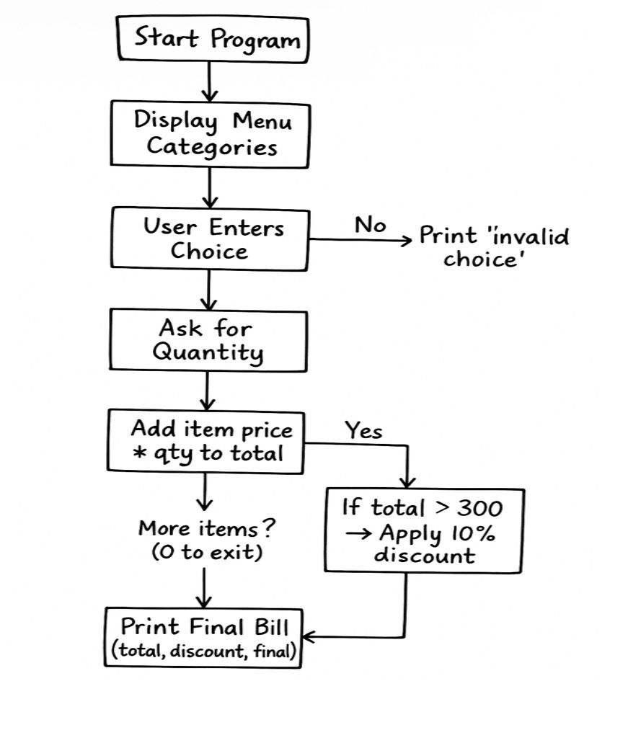

4.2 Algorithm
Algorithm: Restaurant Billing System
- Start
- Define struct menu with name, price, and category
- Initialize 12 items inside an array
- Display menu using printmenu()
- Call takeorder()
  - Ask user for choice
  - If 0 → exit loop
  - Else ask for quantity
  - Add price × quantity to total
- Calculate discount if total ≥ 300
- Print bill using printbill()
- Save bill using savebill()
- End

5. Implementation Details
This section explains the important parts of the code.

5.1 Structure Used
I used a structure to store each menu item’s name, price and category:
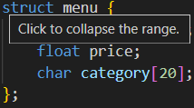

5.2 Menu Initialization
I stored all 12 items inside an array of structures:
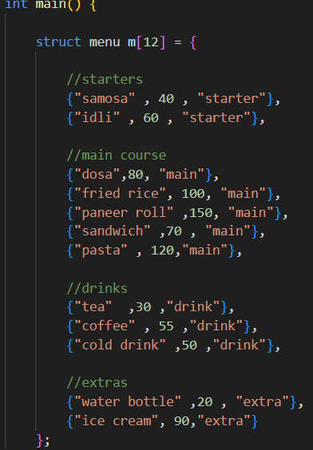

5.3 Printing the Menu
This function prints all items category-wise:
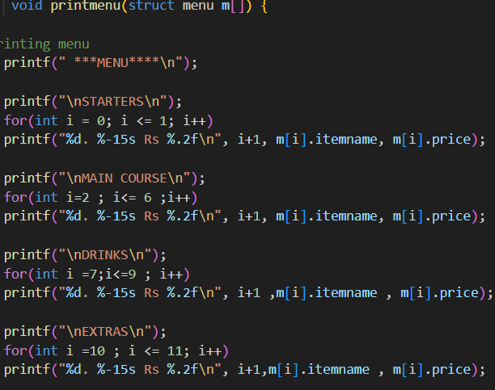

5.4 Taking Orders
I used a loop so the user can order multiple items, customers choice is then validates by checking if it lies between 1 and 12 or not. If not, n “invalid choice” is printed, after that quantity is asked:
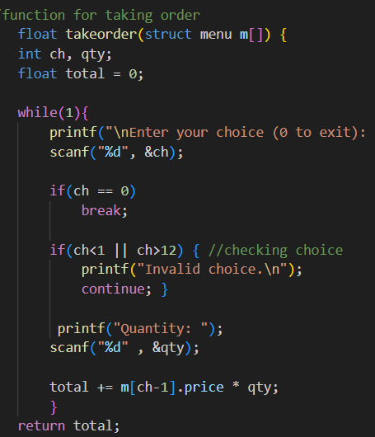

5.5 Printing the Bill
A simple discount of 10% is given if total ≥ 300, and the final bill is calcualated by subtracting discount amount from the total bill:
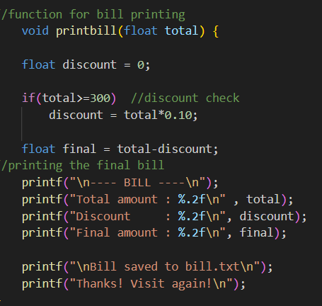

5.6 Saving the Bill (File Handling)
I used a text file to save the final bill in bill.txt:

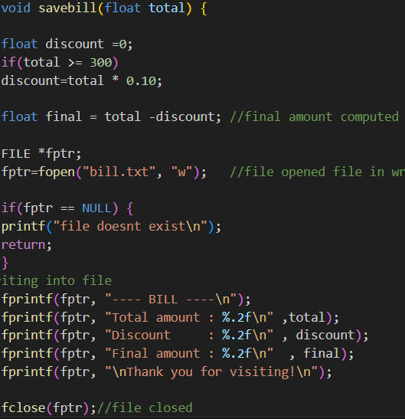

6. Testing & Results
I tested the program with different inputs:

Test 1
- Ordered dosa (1 quantity) rs 80
- Ordered tea (2 quantity) rs 60
- Total = 140
- No discount (because < 300)
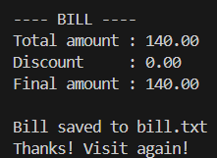 (bill.txt) 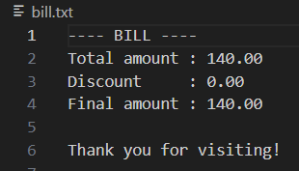

Test 2
- Ordered pasta (2 qty) → 240
- Ordered ice cream (1 qty) → 90
- Total = 330
- Discount = 33
- Final = 297
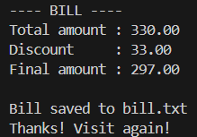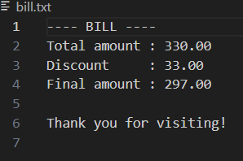
(bill.txt)
The file “bill.txt” was created successfully each time and showed correct values.
Everything worked as expected.

7. Conclusion & Future Work
The project helped me understand how to use structures, functions, loops and file handling together in a single program.
It works well for basic billing.

In the future, I can improve it by:
- Adding GST calculation
- Allowing multiple customers at once
- Storing daily sales in a file
- Adding item codes instead of numbers
- Making a better UI (maybe using graphics)

8. References
- Class notes
- Online C programming tutorials
- Let Us C – Yashwant Kanetkar

